实验一 数理逻辑

姓 名： 杨程锦
学 号： 20212114710
班 级：计算机科学与技术21-1班
实验地点： C204
实验时间： 2022/11/9

- 实验目的和要求
从键盘输入2个命题变元，求出其取非、合取、析取、蕴含、等价连接词的真值表；
对于输入任意的命题公式，输出其真值表；
对于任意命题公式，求其主析取范式、主合取方式，并显示出其表达式。
- 实验环境和工具
环境：C++14 工具：CLion2021.3.2
- 实验结果
  - 程序流程图
主体：
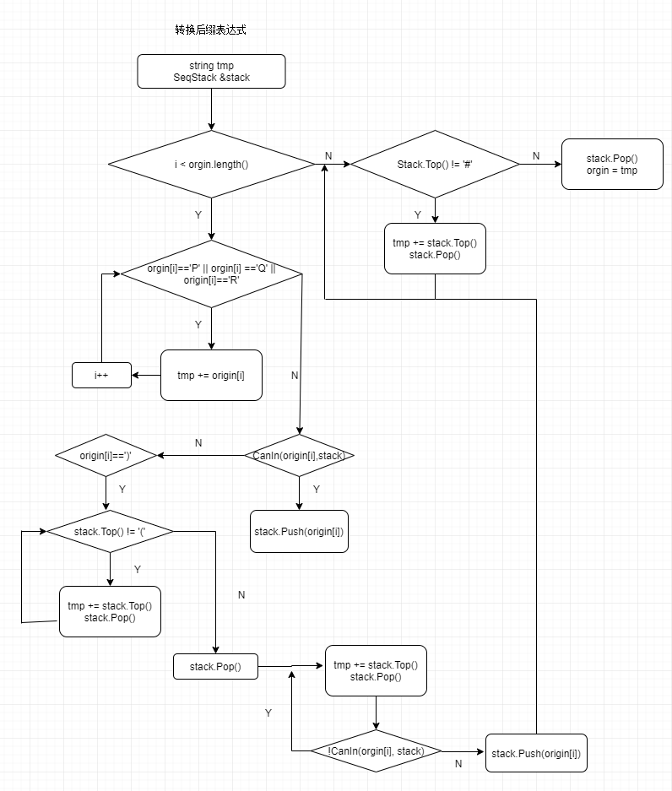
  - 程序核心代码
第一题：
#include <iostream>
using namespace std;

int And(int a,int b) {
int res = a * b;
return res;
}

int Or (int a, int b) {
int res = a + b;
res = res > 0 ? 1 : res;
return res;
}
int Not(int a) {
int res = a == 1 ? 0 : 1;
return res;
}

int If(int a, int b) { //条件
int res = (b == 1 && a == 0) ? 0 : 1;
return res;
}

int Iif(int a, int b) {//双条件
int res = (b == a) ? 1 : 0;
return res;
}
int main() {
int a, b, c;
cout << "请输入两个命题变元的真值：" << endl;
cin >> a >> b;
cout << "合取运算结果：" << And(a, b) << endl;
cout << "析取运算结果：" << Or(a, b) <<endl;
cout << "单条件运算结果：" << If(a, b) <<endl;
cout << "双条件运算结果：" << Iif(a, b) <<endl;

cout << "请输入取非命题变元的真值：" << endl;
cin >> c;
cout << "取非运算结果：" << Not(c) << endl;
}

第二、三题：
#include<iostream>
#include<string>

using namespace std;

class SeqStack {
public:
SeqStack(int mSize);
~SeqStack();
bool Push(char x);
bool Pop();
char Top();
bool Empty();
private:
int top;
char *stack;
int maxtop;
};
SeqStack::SeqStack(int mSize) {
maxtop = mSize - 1;
stack = new char[mSize];
top = -1;
}
SeqStack::~SeqStack() {
delete[]stack;
}
bool SeqStack::Push(char x) {
if (top == maxtop)
return false;
stack[++top] = x;
return true;
}
bool SeqStack::Pop() {
if (-1==top )return false;
top--;
return true;
}
bool SeqStack::Empty() {
if (-1==top)return true;
return false;
}
char SeqStack::Top() {
return stack[top];
}
bool IsLegal(const string orgin) {
for (unsigned int i = 0; i < orgin.length(); i++) {
if (orgin[i] != '(' && orgin[i] != ')' && orgin[i] != 'P' && orgin[i] != 'Q' && orgin[i] != 'R' && orgin[i] != '&' && orgin[i] != '|' && orgin[i] != '=' && orgin[i] != '>'&&orgin[i]!='!')return false;
}
return true;
}

int And(int a,int b, SeqStack &stack) {
int res = a * b;
stack.Push(res);
return res;
}

int Or (int a, int b, SeqStack &stack) {
int res = a + b;
res = res > 0 ? 1 : res;
stack.Push(res);
return res;
}
int Not(int a, SeqStack &stack) {
a = stack.Top();
stack.Pop();
int res = a == 1 ? 0 : 1;
stack.Push(res);
return res;
}

int If(int a, int b, SeqStack &stack) { //条件
int res = (b == 1 && a == 0) ? 0 : 1;
stack.Push(res);
return res;
}

int Iif(int a, int b, SeqStack &stack) {//双条件
int res = (b == a) ? 1 : 0;
stack.Push(res);
return res;
}

bool CanIn(char out,SeqStack &stack) { //先计算优先级，然后判断能否进栈
char in = stack.Top();
int i=0, o=0; //分别表示栈内外运算符的优先级
switch (in) {
case '#':i = 0; break;
case '(':i = 1; break;
case '=':i = 3; break;
case '>':i = 5; break;
case '|':i = 7; break;
case '&':i = 9; break;
case '!':i = 11; break;
case ')':i = 12; break;
}

switch (out) {
case '#':o = 0; break;
case '(':o = 12; break;
case '=':o = 2; break;
case '>':o = 4; break;
case '|':o = 6; break;
case '&':o = 8; break;
case '!':o = 10; break;
case ')':o = 1; break;
}
if (i < o) //栈外优先级比栈内高就进栈
return true;
else
return false;
}

void InfixToPostfix(string &orgin ,SeqStack &stack) { //转换为后缀表达式
string tmp; //保存后缀表达式
stack.Push('#');
for (int i = 0; (unsigned)i <orgin.length(); i++) {
if (orgin[i] == 'P' || orgin[i] == 'Q' || orgin[i] == 'R' ) {
tmp = tmp + orgin[i];
continue;
}
if (CanIn(orgin[i],stack))
stack.Push(orgin[i]);
else if (orgin[i] == ')'){
while (stack.Top() != '('){
tmp = tmp + stack.Top();
stack.Pop();
}
stack.Pop();
}
else{
do{
tmp = tmp + stack.Top();
stack.Pop();
} while (!CanIn(orgin[i],stack));
stack.Push(orgin[i]);
}
}
while (stack.Top() != '#'){
tmp = tmp + stack.Top();
stack.Pop();
}
stack.Pop(); // '#' 出栈
orgin = tmp;
}

int Calculate(int number,string &org,SeqStack &stack, int p, int q, int r){
int value=0,a=0,b=0,res=0;
if (number == 3){
for (int i = 0; (unsigned)i <org.length(); i++){
if (org[i] == 'P' || org[i] == 'Q' || org[i] == 'R'){
value = org[i] == 'P' ? p : org[i] == 'Q' ? q : r;
stack.Push(value);
continue;
}
if (org[i] != '!'){
a = stack.Top();
stack.Pop();
b = stack.Top();
stack.Pop();
}
switch (org[i]){
case '=':res=Iif(a,b,stack); break;
case '>':res=If(a, b, stack); break;
case '|':res=Or(a, b, stack); break;
case '&':res=And(a, b, stack); break;
case '!':res=Not(a, stack); break;
}
}
}
if (number == 2){
for (int i = 0;(unsigned)i <org.length(); i++){
if (org[i] == 'P' || org[i] == 'Q'){
value = org[i] == 'P' ? p : q;
stack.Push(value);
continue;
}
if (org[i] != '!'){
a = stack.Top();
stack.Pop();
b = stack.Top();
stack.Pop();
}
switch (org[i]) {
case '=':res = Iif(a, b, stack); break;
case '>':res = If(a, b, stack); break;
case '|':res = Or(a, b, stack); break;
case '&':res = And(a, b, stack); break;
case '!':res = Not(a, stack); break;
}
}
}
return res;
}
char num2bool(int t) {
if (1 == t)return 'T';
else return 'F';
}

void Print(int number, string &orgin, SeqStack &stack) {
int p, q, r, res;
string pcnf; //主合取范式
string pdnf; //主析取范式
if (number == 3) {
cout << "P\t" << "Q\t" << "R\t" << "Z" << endl;
for (p = 1; p >= 0; p--) {
for (q = 1; q >= 0; q--) {
for (r = 1; r >= 0; r--) {
res = Calculate(3, orgin, stack, p, q, r);
if (res == 1)
pdnf = pdnf + "(" + (p == 1 ? "P" : "!P") + "&" + (q == 1 ? "Q" : "!Q") + "&" //主析取范式
+ (r == 1 ? "R" : "!R") + ")" + " | ";
else
pcnf = pcnf + "(" + (p == 0 ? "P" : "!P") + "|" + (q == 0 ? "Q" : "!Q") + "|" //主合取范式
+ (r == 0 ? "R" : "!R") + ")" + " & ";
char cp, cq, cr, cres;
cp = num2bool(p);
cq = num2bool(q);
cr = num2bool(r);
cres = num2bool(res);
cout << cp << "\t" << cq << "\t" << cr << "\t" << cres << endl;
}
}
}
}
if (number == 2) {
cout << "P\t" << "Q\t" << "Z" << endl;
for (p = 1; p >= 0; p--) {
for (q = 1; q >= 0; q--) {
res=Calculate(2, orgin, stack, p, q, 0);
if (res == 1)
pdnf = pdnf + "(" + (p == 1 ? "P" : "!P") + "&" + (q == 1 ? "Q" : "!Q") + ")" + " | ";
else
pcnf = pcnf + "(" + (p == 0 ? "P" : "!P") + "|" + (q == 0 ? "Q" : "!Q") + ")" + " & ";
char cp, cq, cres;
cp = num2bool(p);
cq = num2bool(q);
cres = num2bool(res);
cout << cp << "\t" << cq << "\t" << cres << endl;
}
}
}
//永真和永假的情况下长度为0
if (pdnf.length() != 0)
pdnf.erase(pdnf.length() - 2);
if (pcnf.length() != 0)
pcnf.erase(pcnf.length() - 2);
cout << "主析取范式：" << pdnf << endl << endl;
cout << "主合取范式：" << pcnf << endl << endl;

}
int main() {
SeqStack stack(200);
int cnt = 0;
string orgin;
int number;

cout << "****************************************" << endl;
cout << "* ! 否定 *" << endl;
cout << "* | 析取 *" << endl;
cout << "* & 合取 *" << endl;
cout << "* > 条件 *" << endl;
cout << "* = 双条件 *" << endl;
cout << "****************************************" << endl;
cout << "请输入变元数量 (2 或 3)" << endl;

loop:cin >> number;
if(2==number)
cout << endl << "变元请用P、Q表示" << endl ;
else if (3==number)
cout << endl << "变元请用P、Q、R表示" << endl;
else {
cout << "请输入2或3： " << endl;
goto loop;
}
cout << "输入命题：";
int flag = 0;

do {
if (flag != 0) {
cout << "输入包含不合法字符，请仔细阅读输入提示并重新输入\n（符号请使用半角英文符号）" << endl;
cout << "输入命题：";
}
cin >> orgin;
flag = 1;
} while (!IsLegal(orgin));
InfixToPostfix(orgin,stack);
Print(number,orgin,stack);
return 0;
}
  - 运行结果
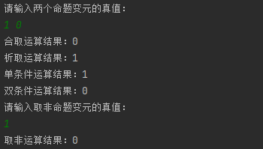
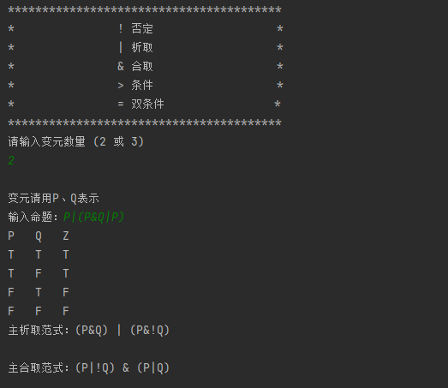

  - 运行结果分析
运行结果正常，可以通过代码实现求任意命题的真值表、主析取范式、主合取范式的功能。
- 实验心得
第一个求变元的运算还是很简单的，第二个求真值表也不是很难，第三个就有难度了。变元只写了2个或者3个变元的情况，因为变元数量如果上去，会导致代码复杂度大幅度提升，由于时间原因，我只写了最简单的两种。并且，变元数量增加之后这种简单的枚举法就不再适用，只能通过寻找一种通用的方法，这样会比较复杂，难度较大。对于本实验，个人认为难度有一些，但是不是特别大，因为数据结构中就使用过后缀表达式等操作，因此有一些基础，对于转换后缀表达式还是有一些经验的，所以写起来相对的不是特别难。

